CYCLADES IST–2000-25456

Final Report (D9.1.4)

Deliverable Type: R
Number: D.9.1.4;
Nature: Report
Contractual Date of Delivery: month 30
Actual Date of Delivery:31/07/2003
Task: WP9

Name of responsible: U.Straccia

Editor : U. Straccia – ISTI-CNR
Via G. moruzzi, 1
56124 Pisa
Italy
Umberto.Straccia@isti.cnr.it

Abstract: This report is the final report of the CYCLADES project. It discusses the work accomplished throughout the entire duration of the project.

- Introduction 3
  - Objectives 3
  - Participants 3
- Organization of the Work 4
- Summary of main project activities and results 6
  - User requirement collection and analysis 6
  - System specification: functionality and architecture 8
User types 8
Use cases 9
Architecture 11
  - Detailed system specification and modules development 13
  - System modules integration, testing and revision 15
  - System evaluation 19
Functionality verification 20
Efficiency evaluation 21
  - System experimentation 22

Introduction

Objectives

The goal of the CYCLADES project is the development of a environment, designed to provide an open collaborative virtual archive environment, which supports users, communities (and their members) with functionality for

- Advanced search in large, heterogeneous, multidisciplinary digital archives

- Collaboration; and

- Filtering and recommendation.

The document base of the CYCLADES system consists mainly of metadata records. Indeed, CYCLADES system uses the protocol specified by the Open Archives Initiative (www.openarchives.org) (OAI) to harvest metadata records from any archive that supports the OAI standard.

Participants

- ERCIM - France (Administrative coordinator)

- ISTI - Consiglio Nazionale delle Ricerche - Italy (Scientific coordinator)

- Foundation for Research and Technology – Hellas

- FIT- Fraunhofer Gesellschaft – Germany

- University of Dortmund

- University of Duisburg Essen – Germany

Project contact point:
Web home Page: www.ercim.org/cyclades

Organization of the Work in CYCLADES

The project has been organised in terms of administrative management and the scientific/technical management.

- Administrative management consisted in directing the administrative work of the project; handle all communication with the project officer; manage the progress and management reports; monitor the project costs and prepare the management reports.

- Scientific/technical management consisted in directing the technical work of the project; monitor the time schedule and the timing of the related activities; recommend appropriate actions to rectify delays; ensure that all project deliverables are available on time; create and maintain the conditions necessary for successful and effective collaboration.

To ensure the working progress and to support the interaction among the partners, regularly technical meetings have been held among the partners. The meetings took place every six month, and the duration of each meeting was approximately one week. Additionally it was decided to rely on the BSCW (Basic Support for Collaborative Work- http://www.bscw.de/) tool, which without doubt contributed to maintain the collaboration among the partner at a high level.

Broadly, the work plan of CYCLADES consisted in:

- User requirement collection and analysis;

- System specification: functionality and architecture;

- Detailed system specification and modules development

- System modules integration, testing and revision;

- System evaluation;

- System experimentation.

The interplay among the parts described above is shown below.
1
2
3
4
5
6

Worth mentioning is the fact that after a six-month first integration phase (part 4), both the system evaluation and the system experimentation phases started in order to provide feedback to the integrated system development phase. This contributed to continuous revisions of parts of the system.

In the following, we will describe in more detail the work and results achieved in the individual parts.

Summary of main project activities and results

User requirement collection and analysis

The User Requirement collection and analysis is the first tool on which to rely in order to determine the CYCLADES system specifications. In order to gather the User Requirements, efforts have been put first on identifying the user communities. Once clearly identified, the second phase consisted in assessing their expectations as users of the CYCLADES environment. A number of scholarly user communities were identified as “relevant” for providing feedback regarding the envisioned environment. These communities include:

- the German Society of Physics

- the German Society of Mathematics

- the Italian Society of Mathematics

- the Delos Network of Excellence in Digital Libraries

- the PLANET Network of Excellence in Artificial Intelligence Planning

Academic and research groups among the partners’ institutions have also been consulted.

The next step consisted in creating the specific questionnaire for eliciting requirements from prospective users of a collaborative archive environment. All partners contributed to the formation of the questionnaire by specifying appropriate questions for the different functional modules of the CYCLADES environment. Considering the different disciplines of the user groups we intended to address with our questionnaire, abstraction of technical details was made in order to produce a set of questions that sufficiently covered the entire system functionality, but which were presented in understandable terms by the scientific community at large. The questionnaire also included a concise description of the CYCLADES objectives and of its different service components. Several versions of the questionnaire were produced, refined as well as modified by the CYCLADES partners.

The outcome of this investigation can be summarized as follows:

- The majority of respondents find the to date functionality provided by the digital document collections they have used insufficient. A minority of the people consulted appear to be willing to tolerate having to use specific client-side software to interact with the CYCLADES system, whereas the majority prefer the use of an unmodified browser.

Regarding the Search & Browse functionality, half the respondents do not wish to use schemas other than Dublin Core in searching and browsing, whereas proposal for other metadata schemas include MARC and XML Schema. The vast majority of answers are expressing an interest for using attribute value – based search and there is a significant interest in specifically searching for person names, dates as well as free text. Half of the respondents wish to query the system using predefined fields; fewer prefer using a single field and only a small percentage appear to be willing to use a formal query language. A strong preference for the ability to formulate Boolean combinations of query conditions is expressed.

- In the Personalization section of the questionnaire, the majority of prospective users wish to subscribe their interests to the system so as to be notified of relevant additions. Furthermore, the majority of respondents wish to receive recommendations by the system as far as the organization of their thematic folders is concerned. The majority would accept being recommended to other users as “users with similar interests”. All the respondents wish to be informed of a community’s topics when they receive community recommendation.

- In the Collection Service part of the questionnaire, respondents wish to define collections either by refining existing collections or by composing them. A very small percentage prefers to use predefined collections only. Half of the respondents favor a list of simple conditions on attribute values as the collection description.

System specification: functionality and architecture

This part defined the core functionality of the CYCLADES system as well as architecture suitable for supporting such system functionality. The functional specification is based on the use case model and has been defined in UML-style. Indeed, user types have been identified and for each user type uses cases have been described. Activity diagrams have been defined for each use case. Finally, the architecture of the CYCLADES system has been defined by grouping the uses cases together into homogenous sets. In the following, we briefly report the user types and uses cases identified and the CYCLADES architecture defined.

User types

All users are persons that are registered to the CYCLADES environment. A user may act in different roles and switch from one role to another during the same CYCLADES session, if she has the rights needed for that role.

CYCLADES identified the following user types.

- Every user can act as a single user;

- A user who is a member of a community can additionally perform actions in a community context, thus acting as a community member;

- A community member with appropriate rights can also administrate a community, thus acting as a community administrator;

- A user who is a member of a project can perform additional actions in the project context. Then, the user is acting as a project member;

- A project member with appropriate rights can administrate a project and its folders. This kind of project member is called a project administrator;

- A user with the appropriate rights can create collections and manage those collections she created herself. Having these rights, she is called a collection registrator;

- A user with the appropriate rights can register or unregister an archive or edit the registration information concerning an archive. This kind of user is called an archive registrator;

- There must be at least one user to grant other users the rights to register archives and collections. This kind of user is called CYCLADES system administrator.

Use cases

Several use cases has been defined for each user type. The main use cases are listed below and can be summarized as follows.

Use cases for a single user

The actions contained in these use cases can be performed by any user of the system, but are limited to the user's private folder structure, respectively to those folders in a community or project folder hierarchy where the user has the appropriate rights. Each folder is a holder of documents related to a topic of interest of a user or of a community. Folders may be organised hierarchically.

- Joining the CYCLADES environment
  - Register as a new user, Login, View and Edit user information

- Folder management
  - Create folder, Manage folders , etc.

- Gathering records
  - Update folder profile
  - Searching and browsing
  - Personalized searching and browsing
  - Receive recommendations from the system

- Exploring and joining communities
  - View a list of communities (with name, description, and contact information) and subscribe to a community
  - Join a community via invitation of an administrator

Use cases for a community

The following actions can be performed in addition to those for the single user, whenever the user is in a community context (i.e. in a community folder).

- Setting up a new community
  - Create a new community topic folder
  - Invite and kick out members of the community, and define access rights for members

- Joining and leaving a community
  - Register after invitation, or subscribe without being invited
  - Leave the community

- Additional record handling in community folders
  - Rate a record
  - Annotate a record

- Awareness
  - Activity reports may be generated to help the user get aware of changes in the

- Communicate with other community members
  - Create and add a comment to a discussion forum

Use cases for collection management

- Create a collection

- Edit collection description

- Delete a collection

Use cases for archive management

The document base of CYCLADES consists of metadata records that can be gathered from OAI compliant digital archives. The use cases are

- Register an archive

- Edit archive registration information

- Unregister an archive

CYCLADES allows to register and de-register archives manually and then starts to gather the data and index them. The extension to the fully automatic process is straightforward, once a registry of OAI compliant archives is available on the Web.
Recently, this list is available from

http://www.openarchives.org/Register/ListFriends.pl

but, there was to time to adjust CYCLADES to read this list in automatically.

Architecture

The CYCLADES system consists of the following services:

- Access Service

- Collaborative Work Service

- Search and Browse Service

- Collection Service

- Filtering and Recommendation Service

- Mediator Service

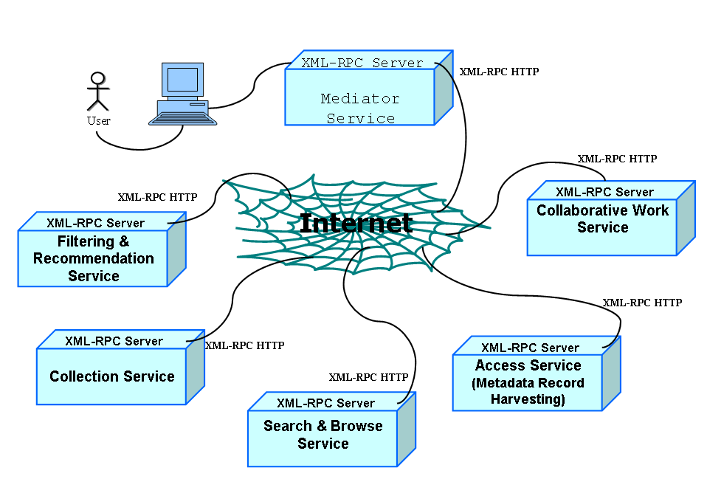

Most of the services provide their own user interface, i.e. the Collaborative Work Service, the Search and Browse Service, the Access Service (for archive management), and the Collection Service (for collection management). The Mediator itself provides the registration and login interface, and a system administration interface (for assigning access rights, etc.).

The Access Service interacts with the underlying metadata archives, adhering to the Open Archives specification.

The Collaborative Work Service provides a folder environment for managing records, queries, collections, documents, and annotations, supports collaboration between users by way of folder sharing in communities and projects. One component of this service is the Rating Management Service, which manages ratings.

The Search and Browse Service supports the activity of searching records from the various collections, formulating and reusing queries, and browsing schemas, attribute values, and metadata records.

The Collection Service manages collections, thus allowing a partitioning of the information space according to the users' interests and making the individual archives transparent to the user.

The Filtering and Recommendation Service provides personalized filtering of queries and query results, recommendations, and personalized folder management.

The Mediator Service acts as a registry for the other services and provides security, i.e. it checks if a user is entitled to use the system, and ensures that the other services are only called after proper authentication.

The services of the CYCLADES system communicate via HTTP, using XML-RPC (http://www.xmlrpc.com/spec}).

Detailed system specification and modules development

The main goal of the System Development phase was twofold. On one hand the exact system specification, i.e. the definition of the API (Application Programming Interface) and, on the other hand, the development of the individual services defined within the CYCLADES system. The exact definition of the API guaranteed that the services communicate provide the right functionality with the right parameters. This, together with the uniform communication protocol allowed the development of the services remotely at each partner’s location. The methodology followed for the detailed system specification is UML-like. In particular, for each use case defined during the specification phase,

- process flow;

- service interaction diagrams;

- method signatures;

- service internal architecture; and

- the logical user interface

have been defined.

Below, an excerpt of method specification and interaction diagram of a Search and Browse Service functionality.

Example of process flow

The search and browse process consists of the following steps:

- System: determines the list of collections that are associated to the user's current folder, or (if there are no collections associated to the folder) the user's personal list of collections, and presents the list to the user to browse

- User: selects collections to search, or requests to Search,
  - all collections associated to the folder, or
  - all of her personal collections, or
  - all collections in the system

- System: determines the list of queries stored in the user's current folder, and the list of queries the user has submitted during the same search and browse session before (if there are none, this step and the following step are skipped)

- User: selects an existing query, or decides to formulate a new one

- System: presents the user the query formulation interface, with the appropriate fields filled in if the user selected an existing query in the previous step

- User: edits the query this comprises adding, changing, or deleting query conditions

- User: saves the query to the current folder, if she wants to re-use it later (this results in the system copying the query to the Collaborative Work Service for persistent storing)

- User: submits the query, with or without personalization

- System: executes the query and presents a result set of records to the user, ranked by estimated relevance

- User: browses the result set, or previous result sets still existing from this search and browse session, possibly selects records to be saved to the current folder

- System: if there are any records to be saved, the system passes them to the Collaborative Work Service.

Example of interaction diagram

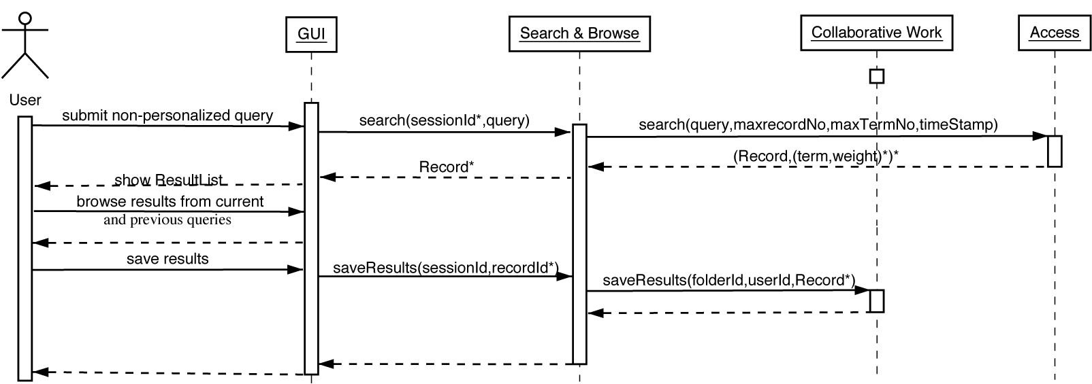

Example of method specification

- HTML initiateSearch(folderId,userId)
  - Description: this method can be called to initiate a search and browse session for the given folderId and userId, it returns the initial SBS interface page to the caller
  - Input.
    - userId: the id of user who started the search
    - folderId: the id of the folder the user started the search form
  - Output. the first page of the Search and Browse Service GUI

System modules integration, testing and revision

In this phase, the goal consists of

- to integrate the single system components into the CYCLADES system;

- to test the single system components;

- to test the integrated system;

- to perform system debugging and produce a definite release, according to the feedback collected during the validation and experimentation phase.

Concerning the integration phase, it has been addressed incrementally. Indeed, in each step a list of uses cases has been chosen with the goal to make them `running’ within the system. By relying on the interaction diagrams, a set of methods are identified which should be integrated within the CYCLADES environment. Parallel to the integration, a testing of the integrated method for correctness has been undergone. The test strategy consisted in two phases:

- component testing

- integrated system testing

The result of component testing are debugged stand-alone service components, the result of integrated system testing is a debugged version of the integrated CYCLADES functionality.

The component-testing phase, the CYCLADES service components were tested in a stand-alone manner, without communication with other components. The API of each service component was tested on conformance to the specification. An up-to-date API specification of each service component is also part of this report. The tests were based on a number of test data per API method. Attention was also paid to robustness, i.e. the ability to deal with ``wrong" input data. Partners who developed a component carried out a comprehensive test of their own API. Additionally, developers of components, which call another component, also tested the methods they call. For components that have a graphical user interface (GUI), the component test included a test of this GUI. In general, the developers of a component carried out the GUI tests. The GUI tests ensured that the use cases work according to specification. The components were tested running on a developing partner's host, the testing was carried over the Internet via HTTP, either from an XML-RPC client for the API or a Web browser for the GUI. Errors that were detected during the component tests were reported back to the developers of the component who in turn took care of fixing the bugs. At the end of the component-testing phase, new versions of the components were generated where necessary. The debugged service components served as basis for the system integration.

Every test of a single component or the integrated system is documented in a test report. Test reports include the following data:

- Name and email address of the tester;

- Date and time when the test was performed;

- Scope of test, e.g. for component API testing the name and version of the service component and the part of the API that has been tested;

- Test environment including operating system and type of test client, e.g. programming language and XML-RPC library used for component API testing, or Web browser used for GUI testing;

- Test plan, i.e. the list of test cases giving method/use case and input parameters used;

- Test log listing the outcome of the test case executions (manual testing or automated testing via scripts);

- Summary of test results;

- Recommendation for action when errors had been encountered.

After the completion of the component-testing phase, all methods were tested. After revisions, all the methods worked according to the specification for all sets of correct input parameters. Correct calls did not produce errors; incorrect calls produced the appropriate error codes and messages.

Below, an excerpt of test plans and test log related to the Access Service

Tester: Saadia Malik (malik@is.informatik.uni-duisburg.de)
Test date: 6 March 2003
Scope of test: Testing CWS API methods called from AS
Test environment: Test client was a Java (Java version 1.4.0\_02, Java(TM) 2 Runtime Environment, Standard Edition (build 1.4.0\_02-b02)} application running on Debian Linux, the XML-RPC implementation of Apache XML Project.

Test plan: Each method was called first with valid parameters, then with invalid parameters of the right type, then with a wrong number of parameters, and finally, with a wrong parameter type.

With the valid method calls, the semantic result was checked:

GetId: did return the service ID
GetArchives: the archives known to the AC were returned
GetArchiveDescription: returned Archive description including textual description, list of keywords, list of schemas, list of language, temporal coverage

…

With the intentionally invalid calls, it was checked whether the method returned the appropriate error code and message.

Test log:
An excerpt of the last test log is shown below.

===========================================
07.03.2003 15:55:15: Method.3=getArchiveDescription
07.03.2003 15:55:15: comment.3=No parameter is given
07.03.2003 15:55:15: flags.3=

07.03.2003 15:55:15: TestService: XML-RPC Fault #10001 -
org.apache.xmlrpc.XmlRpcException: Bad number of parameters
(getArchiveDescription):
got 0, expected 1
07.03.2003 15:55:15: TestService: spent 66 millis for request

After the CYCLADES system services had been successfully tested, the components were integrated into a first version of the CYCLADES working service environment. This was done by having the components communicate using the inter-service communication protocol XML-RPC making use of the diverse service APIs, and by directly invoking the graphical user interfaces of other components at the integrated CYCLADES graphical user interface. The single service components resided on a developing partner's host.

Integrated system testing uses as a general test plan the use cases as described in the system specification phase, focusing specifically on use cases that involve inter-service communication (the other use cases have been tested during component testing). When integrated system functionality is to be tested that involved more than one user, the existing use cases are extended, or two or more use cases are put together to form a multi-user test case. The interaction diagrams served as a checklist for the integrated systems testing because they typically represent system functionality that involves inter-service communication.

The test plan for the integrated system test of the CYCLADES system comprises all use cases that involve more than one service. The test cases are executed from the initiating service. A user will normally do this from the service GUI; with some use cases, however, the execution is triggered by a service internal schedule, e.g. folder profile update at scheduled time. The effects of the inter-service communication are checked with the services involved to confirm a successful test, e.g. registering with the Mediator Service should also create a user and home folder object in the Collaborative Work Service.

Below, an excerpt of a use case test, involving the Mediator Service.

Tester: Thomas Kreifelts (kreifelts@fit.fraunhofer.de)
Test date: February 25 14:19:23 MET 2003
Scope of test: All test cases of Mediator Service were tested.
Test environment: Test client was a Netscape 4.7 browser on a SUN workstation running Solaris.
Test plan: The MS test cases as listed above were tested for a new user.
Test summary: All test cases worked according to specification. However, a button or link to start the interaction to become a collection administrator was not found in the MS GUI.

After the completion of the integrated testing phase, all use cases were tested. After revisions, all the use cases worked according to the specification.

System evaluation

During this phase, the integrated CYCLADES system has been validated. The validation of the CYCLADES system prototype was subdivided into two distinct tasks:

- functionality verification

- efficiency evaluation

Firstly, the functionality of the system was tested. The aim of functionality testing was to verify that the prototype implemented has met all the functionality requirements defined during the specification phase. More specifically it was be tested for all the use cases defined, that they could be fully completed by a user of the prototype.

Secondly, the performance of the prototype implementation was tested with the aim of determining the efficiency with which the system completes its tasks even under taxing circumstances, as e.g. heavy load, great amounts of data, or the loss of connection to one or more of its service components. For this purpose several experiments were conducted, using simulated user input under controlled situation. The performance of the services was tested at use case level, and where necessary and helpful for determining a possible loss in performance also at the method level.

These tests were carried out using a web browser for GUI based test, or special test clients for automatically generated HTTP or XML-RPC calls, that were used to simulate user input.

Where shortcomings in functionality or performance became visible, this was used as a basis for improving the current prototype to produce an overall more efficient and usable system.

Functionality verification

The test plan consists on going through the uses cases by performing the steps to complete them, reporting a log, a test result and a summary.

Below, an excerpt concerning the validation of a use case involving the Access Service.

Tester: Sascha Kriewel, University of Duisburg-Essen (sascha.kriewel@uni-duisburg.de)
Test date: April 7th, 2003
Scope of test: Registering a new archive
Test environment: Mozilla 1.2b [Mozilla/5.0 (X11; U; Linux i686; en-US; rv:1.2b) Gecko/20021016] on Debian Linux (Kernel 2.4)
Test plan: For testing the functionality of the Access Service part of the system we will be going trough the use case of Archive Management listed above. For the use case we will perform the steps from logging into the system until.
- Use Case: Registering a new archive
  - call the Archive Management GUI
  - register a new archiv
  - enter the URL of an OAI compliant repository
  - edit the archive information
  - submit the registration request

Test log: Use cases tested: Registering a new archive.
Test completed. Location of test log:

http://bscw.gmd.de/bscw/bscw.cgi/d41936214/AS_fun_tests.log

Summary of the results from test:
The use case that was previously defined for the Archive Management could be completed successfully. Recommendations for any action to be taken, where applicable: None.

After revisions, all uses cases has been successfully validated.

Efficiency evaluation

The aim of efficiency testing of the CYCLADES prototype was to quantify the performance of the various components as well as the overall system. Towards this end we determined

- average response time to user requests;

- system scalability; and

- system stability.

The efficiency testing was split into two phases. During the first phase the performance of the implemented methods was tested, using an XML-RPC test client. The methods were subjected to stress tests by forcing them to handle an increasing number of concurrent requests at once, and also by testing them with large amount of data. By this a better view of the scalability of implemented prototype was to be gained.

In a similar manner, the system as a whole was tested for its performance, by going through all defined use cases, and noting the efficiency with which the system carried them out, but also the scalability of the system regarding large numbers of user requests and large amounts of data.

Where necessary, a revision of CYCLADES components took place to meet reasonable efficiency.

As usual, for each method and for each use case a test plan is provided, a test log and a summary.

Below, excerpts of a performance test.

Tester: Sascha Kriewel, University of Duisburg-Essen (sascha.kriewel@uni-duisburg.de)
Test date: April 8th, 2003
Scope of test: getId method
Test environment: JMeter 1.8.1, Mozilla 1.2b [Mozilla/5.0 (X11; U; Linux i686; en-US; rv:1.2b) Gecko/20021016] on Debian Linux (Kernel 2.4)
Test plan: To measure the API efficiency, each method call was simulated using the XML-RPC with the help of the JMeter application. For each method, a test plan was made that is composed of an XML document containing the method name and the parameters passed, and a thread group containing the information of concurrent calls sent and number of times these concurrent calls are sent. The following numbers of concurrent calls are sent to each method: 1, 5, 10, 15, 20. Each of these concurrency runs is sent several times to determine an average result. During this, method response time and errors are observed.

Test log

Average Response Time:

concurrent | | total | average | results
requests | loops | runs | response-time | o.k.?
------------------------------------------------------------------------
1 | 200 | 200 | 476ms | x
5 | 40 | 200 | 1667ms ~ 2s | x
10 | 20 | 200 | 2081ms ~ 2s | x
15 | 15 | 225 | 2449ms ~ 2s | x
20 | 10 | 200 | 3608ms ~ 4s | x

All the methods are working very efficiently with the exception of search. This method threw exceptions under heavy load. Otherwise overall average response time didn't exceed 4 seconds.

System experimentation

This part addressed system experimentation of CYCLADES on a large scale by allowing users to access to the CYCLADES system worldwide. This part conducted a user evaluation to measure the acceptance and usability of the specific functionalities provided by the CYCLADES system. To gain insight into the users’ perception of the system a web based questionnaire was developed and analysed.

The complexity of the system requires guiding the user into the system without overwhelming her with the complete set of functions and implicated concepts that establish the strength of CYCLADES. Therefore, we prepared the ‘Quick start to CYCLADES’ to give a fast introduction into the system to the interested user. This quick start explains the very first steps necessary to use the CYCLADES system, explains the most important functions and shows some very elementary actions to the user. With this aid she gets an idea of the concepts behind CYCLADES and how the user interface is structured. This quick start is implemented as web pages that are linked in a nonlinear way. It lets the user choose, whether she wants to follow the quick start step by step or if she wants to skip one part and choose another subject from a table of content. The parts contained in the quick start cover:

- Communities and Folder Handling

- Searching Archives

- Collections

- Advanced Search Features

- Community Management

- Recommendations

To evaluate the users’ satisfaction with the usage of the CYCLADES system, we have chosen to take two different data sources into account. Firstly we created a web-based questionnaire and secondly we recorded the actions that users performed during the use of the system. All active users have been asked to fill in the questionnaire.

Several actions have been undertaken to spread the information that the CYCLADES prototype was available for public use and exploration, e-mail list, demos, publications. At the same time we announced the evaluation and the questionnaire and asked for user feedback.

Overall the CYCLADES system received an intermediate appraisal. Apparently the system raised large groups of interested users, the response was amazing and the registered users display a variety of different backgrounds.

But, we also discovered some possible reasons why the expectations of some users were apparently not met.

One reason is that the CYCLADES version tested is still a prototype. The performance of the system was not at any time of the test period impeccable. The functions are hosted at the different institutions involved. Some occasions occurred when due to technical challenges certain parts of the system were not working when people tried to use them. After such an experience these users most probably did not try too often to accomplish their exploration. Some of these impressions might have found their expression in the questionnaire.

Also, some advanced functionality of the CYCLADES system has not been used by some respondents (e.g. advanced search, filtered search). The reason may rely on the fact that the introduction to the system might have been insufficient. Due to the high complexity of the CYCLADES system a help exceeding the quick start might have been indicated. The quick start was in fact often mentioned as a great help, but regarding the complex system and the variety of functions, it should be considered for future use if the conducting of trainings or other forms of introduction might be more appropriate.

Another point that can be noticed is the fact that the ratings of the users on the 1-to-4 scales are often widespread using the whole range of the scale. We assume that this is partly due to the fact that the respondents differ in their background and precognition in computer use. They have different experience with databases, virtual libraries and community platforms. Coherently their assessment of the CYCLADES system and functions also differs. Since the CYCLADES is thought to address all user groups it ought to be usable without trouble even by computer laities. Therefore we did not survey the computer related knowledge.

