Cyclades IST-2000-25456

An Open Collaborative Virtual Archive Environment

Dissemination and Use Plan (D7.2.1)

Deliverable Type: R
Number: D.7.2.1;
Nature: Report
Contractual Date of Delivery: month 6
Actual Date of Delivery: 10 August 2001
Task: WP7

Name of responsible: B. Le Dantec

Editor : B. Le Dantec – ERCIM
R. Ronchaud – ERCIM
2004, route des Lucioles
B.P. 93
06902 Sophia Antipolis
France
Bruno.le_dantec@ercim.org

Remi.ronchaud@ercim.org

Abstract:
The Dissemination and Use Plan is describing the general efforts that are, and will be, dedicated to the promotion of the Cyclades project, both outside and inside the consortium, while presenting the use plan corresponding. This will provide the Cyclades project with a preliminary exploitation plan to rely upon for the preparation of the final Technology Implementation Plan.

Keyword List:
Dissemination tool, Web, Exploitation plan, expected results, Technology Implementation Plan.

Dissemination and Use Plan (D7.2.1): Table of Content

1
Table of Content 2

Introduction 3

Part I Dissemination 3

External dissemination 3
Internal dissemination 7
Monitoring and evaluation methods of the Dissemination Plan 9

Part II Dissemination Plan 9

Months 1-6 (November 2000-April 2001) 9
Months 7- 12 (May-October 2001) 10
Months 13 - 18 (November 2001-April 2002) 10
Months 19-24 (May - October 2002) 10
Months 25-30 (November 2002-April 2003) 11

Part III Use Plan 11

The Cyclades Preliminary Exploitation Plan 11

Use Plan per partner _______________________________________________________________________12

ERCIM 12
CNR 14
ICS-FORTH 15
GMD-FIT 16
University of Dortmund 17

Synthesis and Conclusions 19

Introduction

The Dissemination and Use Plan (DUP) describes schemes for the dissemination of knowledge gained during the project, and (to the extent that this is possible during the first six months of the project) the plans for promotion of the operational Cyclades system. This Deliverable should then tackle the following two points:

1. Ongoing dissemination throughout the project lifetime and
2. Draft promotional plans for the operational Cyclades system.

The Dissemination Plan reviews the information to be disseminated, the dissemination media options and agenda for dissemination. The Use plan is a first step towards the Technology Implementation Plan (TIP, D9.1.3), which is written at the end of the project as it is due at month 30. The TIP will describe the participants’ actual achievements in dissemination and their plans at that time for the exploitation of their results. The TIP will, where appropriate, refer to the present Dissemination and Use plan, indicating how and whether anticipated activities actually took place or were modified in the light of circumstances (or where other actions and measures initially unplanned were introduced).

The production of the Dissemination and Use Plan forms an important part of the first stage of the project work. An internal review and study of the DUP will be undertaken before defining the TIP. The TIP will be structured accordingly to the European Commission’s recommendations by precising for each partner how it will exploit project results within its organisation. It will then describe for each individual partner the results available through them for exploitation by others and finally the TIP will propose a summary by the Project Co-ordinator of the European added value from the project as a whole.

Part I Dissemination

External dissemination

In order to immediately improve the Project visibility, a logo was designed and is to be used in all the dissemination tools, ranking from the web site to fact sheet and posters:



Cyclades Web Site

The first Dissemination task is the creation of a dedicated Web page. The Cyclades web site (http://www.ercim.org/cyclades) has been created to provide various information related to the project. It includes a restricted area for the Consortium, mainly used as document repository, and a public section. The site has been opened for public access in January 2001.

All the relevant information regarding the Cyclades web site are to be found in the corresponding Deliverable, Project Web Site, D7.1.1

The server is run by staff from ERCIM and is regularly updated.

The CYCLADES web site (http://www.ercim.org/cyclades) has been created as a main dissemination tool. Not only does it present the goals and objectives of the project in itself, but it also provides information on its on going activities aiming at the creation of a Open Collaborative Virtual Archive Environment in the field of Digital Libraries. This web site focuses on information dissemination both outside and within the circle of members.

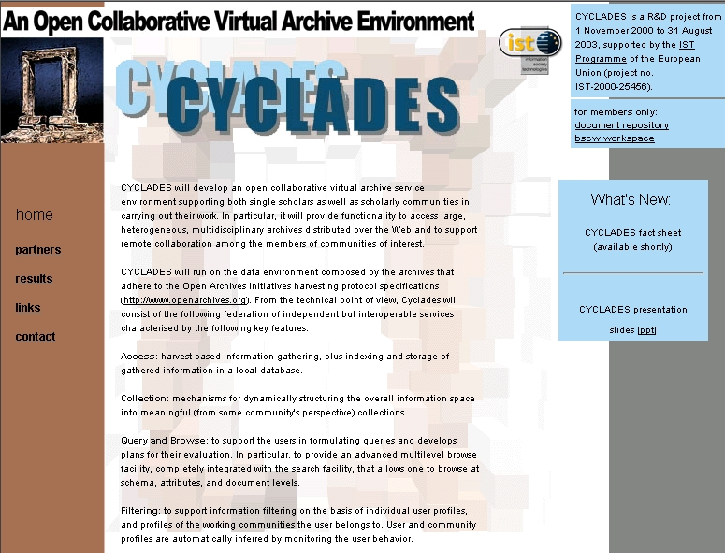

Cyclades web site home page

Dissemination among the Scientific Community

On top of every respective Cyclades member’s plan for the project promotion, ERCIM, being a grouping of 13 Research Institutes in Europe, will use its member network to support the Dissemination plan.

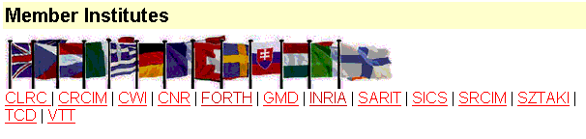

Every ERCIM member has been informed about the project and is given a regular update on Cyclades either through internal project reviews or through the web site. This will ensure an efficient dissemination not only in Europe, but also within the Scientific Community.

Every Cyclades partner annual reporting activity bulletin will state the project, describe its goals and the final system’s potential. It should also state the project’s progress and achievements. Each Cyclades partner will focus on promoting the project through its network of European contacts: research Institutes, national institutions as well as Industrial partners.

ERCIM News

Advertising through ERCIM news (7000 copies) or through other specialised bulletins provides an excellent vector for dissemination. ERCIM News reports on joint actions of the ERCIM partners, and aims to reflect the contribution made by ERCIM to the European Community in Information Technology.

Through short articles and news items, it provides a forum for the exchange of information between the institutes and also with the wider scientific community. ERCIM News is published quarterly and is also available on the ERCIM web site. The printed edition has a circulation of over 7000 copies. Cyclades has already been described in ERCIM News No.45, April 2001, in a short article written by Donatella Castelli.

Cyclades leaflet

This document is to be prepared by the end of August 2001. It is an abstract presenting Cyclades, the project team as well as the goals of the project. This document will be a useful handout for introducing the project as the first step of dissemination.

A specific Project leaflet has been already printed in English and German and is being distributed at conferences (e.g., ECSCW 2001 in September in Bonn, Germany) and to visitors of GMD-FIT.

An Cyclades Poster will be designed and realised to be displayed during various Meetings and Conferences.

Meetings and Conferences

Apart from promoting the Cyclades project world-wide, especially to the Open Archive Initiative community, through traditional scientific channels, the Cyclades partners are inclined to present several significant research achievements in conferences like:

- ECDL 2002 (European Conference on Digital Libraries)
- SIGIR 2002 (International ACM SIGIR Conference on Research and Development in Information Retrieval)
- CIKM 2002 (International Conference on Information and Knowledge Management)
- ACM DL 2002 (ACM Conference on Digital Libraries)
- IuK (Information and Communication of the Learned Societies in Germany
(http://www.iuk-initiative.org/)

On a different level, some partners have planed to present the work done within CYCLADES in forums such as:
- the DELOS Network of Excellence in Digital Libraries Workshop Series,
- the Conferences on the WWW,
- the Workshop Series on the Semantic Web,

Other participation are also foreseen to a panel on:
- ‘e-Democracy: A Panacea or Pandora’s Box?’ at the 14th Bled Electronic Commerce Conference
- ‘e-Everything: e-Commerce, e-Government, e-Household, e-Democracy’

Through these discussion , the promotion of CYCLADES will be made targeting the e-Democracy and virtual communities.

Furthermore, these participations to meeting and forums will be supported by several publications.

Publications:

We will publish the results of work carried out in the Cyclades project in leading Information Retrieval and Digital Library journals like:

- ERCIM News
- D-Lib Magazine
- Journal of the ASIST
- SIGMOD Record
- Information Processing and Management
- ACM Transaction on Information Systems
- Information Retrieval
- International Journal of Digital Libraries

Internal dissemination

Even if it is not the core of the Dissemination plan, several efforts have been devoted to the promotion of the Cyclades project among the partner’s institutes. The goal of this internal dissemination is not so much to broaden the target audience but rather to develop, along with a team spirit, the links between the research institutes and the Cyclades project in particular.

Every partner involved in Cyclades is already driven towards promoting the project in its institute. This is generally the result of an internal policy designed to support challenging research programme as well as advertising the competence of specific departments.

In that perspective, means of dissemination vary : annual review meetings, internal video conferences, publications… Several partners such as GMD-FIT have also developed a specific web site within their institute (cf. http://fit.gmd.de/projects/cyclades/ ) to promote the project.

ERCIM has presented the project to its 13 Members Institutes, and will go on disseminating information during the project’s lifetime. Not only is the project introduced to ERCIM members but the strategy is also to stimulate dissemination from every Institute. Every Cyclades partner is expected to have adopted the same dissemination logic when the project was initiated.

To support this strategy, the Cyclades leaflet handout will give an overview of the project. For additional information about the project, its achievements or participants, the audience is redirected towards the Cyclades web site.

The Cyclades web site has two profiles, one made of free access pages, the other being a restricted area for members. Here are the information available in the Restricted access area (restricted to partners):

- Full project proposal (With scientific part, partners description)
- Address book
- Project meetings (announcement, minutes)
- Management reports, documents
- Administrative and financial guidelines
- Working documents
- Deliverables

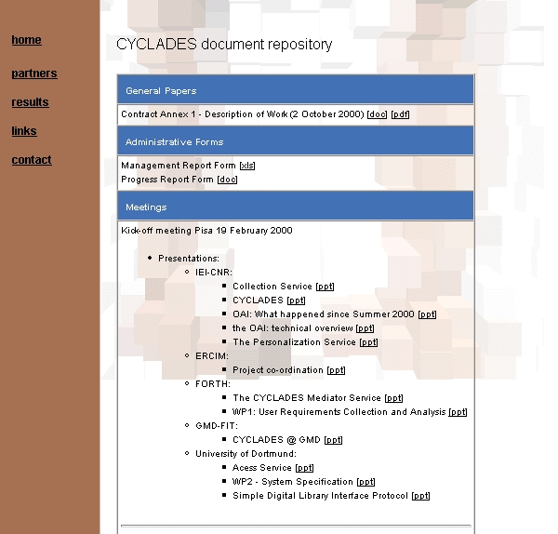
Restricted access area

The web site has a direct link to the BSCW (Basic Support for Cooperative Work) Cyclades workspace. This is not only a document repository for current documents and deliverables. The BSCW enables collaboration over the Web and is a 'shared workspace' system which supports document upload, event notification, group management. It now provides the Cyclades partners with information and tools such as :
- an assessment of the downloaded documents
- a rapid overview of the visit frequency
- the name of the partners who downloaded the document
- the date of uploads and downloads for every document

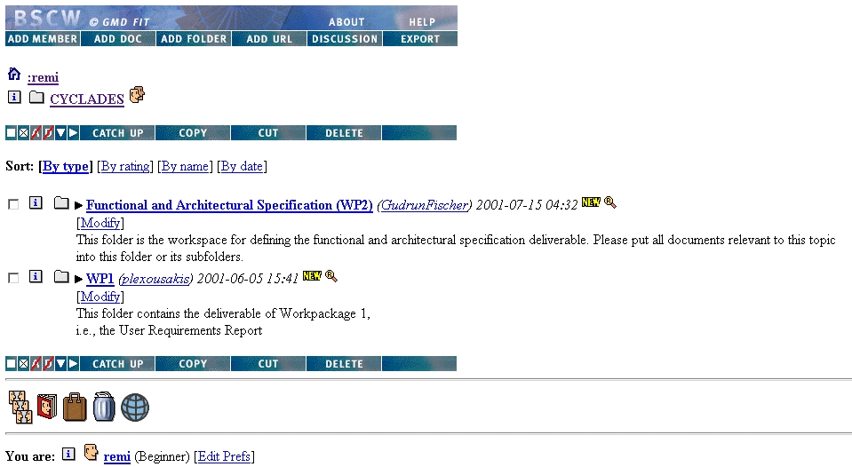

Cyclades BSCW workspace

Monitoring and evaluation methods of the Dissemination Plan

To determine our target audiences and to help us achieve our dissemination objectives, we shall conduct monitoring and evaluation methods throughout the project. The data gathered will be particularly important to decide upon promotional materials (particularly during the final year of the project) and the perspective for conference papers, articles and email announcements.

In that sense, we are using a web trends statistics tool to allow us monitor patterns of usage of the Web site. As well as giving us insights into the kinds of users we are attracting to the site over time, the statistics also provide useful indication of 'gaps' that might be filled by further promotional activity. We can also assess, to a certain extent, the effectiveness of other promotional and dissemination activities. For example, when the next article about Cyclades will appear in ERCIM News, we will be able to assess the increase in our web page consultancy.

The statistics also indicate which sites are referring most visitors to the Cyclades Web (currently ERCIM’s), which browsers are being used to find the site (currently Netscape and MSIE) and which countries are the highest (France, Italy, Greece and Germany). We can also track users' 'paths' through the site to see which pages are being visited: if vital information is being missed in most users' navigation of the site, this will inform our promotion and dissemination activity as well as the structure of the site. Details of documents downloaded (and in which format) will help us determine what visitors to the Web site find of most interest and in which formats they prefer to see information.

Part II Dissemination Plan

Months 1-6 (February 2001-July 2001)

The objective for dissemination and support over the first six months was to announce the start of the project and raise awareness of its aims, objectives and scope. It was also meant to encourage interested parties – particularly those involved in related projects and initiatives – to find out more about the project’s work.

The first six months of the project have already involved considerable dissemination activity with the of the fact sheet and other elements to emphasise project identity, the Web site, articles in the ERCIM News. The Web site has been kept up to date on a regular basis.

These dissemination elements have been widely advertised through mailing lists in partners’ countries, in English and in translation. The 13 European Research Institutes that are ERCIM members have been regularly informed on the project and are also relaying this information in their respective spheres of influence.

A programme for monitoring use of the Web site was installed and is already providing useful information on origin of users and patterns of behaviour when visiting the site.

Months 7- 12 (August 2001- January 2002)

During this time the project moves further into its data gathering and research phase. Regarding dissemination, the focus will continue to be on related projects, services and initiatives. Potential end users may also hear of the project, but they are not prime targets for the moment, although the web site, articles and posters are bound to reach this audience.

The ERCIM News will continue to be issued every three months, announcing the main achievements of the project’s research. During that period, WP8 will encourage other partners to contribute to writing of articles.

Particular attention will be paid during this period to the distribution of new promotional materials and maintenance of the project's profile though the Web site.

The monitoring of the Web site statistics will carry on, with a view to improving visitors' paths through the site and drawing attention to key information, as well as providing a focus for dissemination activity by proving additional links to DL related projects, not only in Europe but also world-wide.

In that perspective, the Cyclades team will devote specific efforts to promoting the Cyclades environment to the Open Archive Initiative, and this throughout the entire project life time, and beyond if necessary.

Months 13 - 18 (February 2002- July 2002)

Much of the early part of this period will focus on targeting more precisely dissemination through conference and international workshops. The level and frequency of participation required will depend upon the number of contacts with potential participants that are generated by our work. Hopefully, a more detailed and advanced presentation of the final system architecture and functionnalities will be then available.

The results of these presentations of Cyclades will give us more elements to write the final exploitation plan due at T+30. This first version of the exploitation plan will not only benefit from the elements gathered from our presentations, but will also find additional inspiration in their respective feedback.

As the project moves towards its final year, the support and collaboration with other DL oriented projects will need to be ensured. Their awareness of the project progress and recommendations will prove useful for the final implementation phase.

Months 19-24 (August 2002 - January 2003)

As the project will be approaching its final stage, the attention will be put on improving the draft exploitation plan. A particular effort will be dedicated to analysing the impact data collected through our web site statistics, feed back from potential users, advises from teams involved in other projects. Once gathered together these elements will form a solid basis for improving the exploitation plan.

Emphasis will be put on using different dissemination tools beyond the web site, ERCIM news, meeting. Project partners will need to be consulted on the best approach, but this is likely to involve papers in conferences, articles in relevant journals, letters or press releases to officials' offices and some face-to-face meetings. The experience of some partners in this domain will prove most useful.

The web site could be used as an interactive platform for Institutes or companies interested in Cyclades to submit new ideas or exploitation tracks. It is expected at this point that collaboration with the Open Archive Initiative (OAI) will start to bear fruit and that an efficient dissemination in the US could be achieved through the OAI connections and scientific community networks.

Months 25-30 (February 2003- July 2003)

The last six months of the project will focus on achieving the implementation of Cyclades. The last version of the Final Exploitation Plan will have to be achieved ready not only as the Commission’ Deliverable due a T+30 but also for real terrain implementation.

This Exploitation Plan will be reviewed through a final internal meeting, on the basis of Web site statistics, feedback from visitors to the Web site and any correspondence following publication of articles or announcements on mailing lists.

A full review of the dissemination media and methods used during the first two years of the project will provide a useful basis for an efficient exploitation scheme. These will include a review of the look and feel of the new system, development of new promotional material, a campaign for end users and the media. Papers, posters, distribution of material and articles updating on project findings will keep the project's profile high.

Part III Use Plan

The Cyclades Preliminary Exploitation Plan

Together with the Dissemination Plan, this Preliminary Exploitation Plan is the first attempt of the Cyclades consortium to define its strategy vis a vis the exploitation of the Cyclades Environment. These documents are defining the schemes for the dissemination of knowledge gained during the project, and (to the extent that this is possible after the first six months of the project) the plans for exploitation of the fully-operational Cyclades system.

While the Dissemination Plan reviews the information to be disseminated inside and mainly outside the consortium, precising the dissemination media options and the agenda, the present Use Plan has for counterpart the Technology Implementation Plan, to be delivered at the end of the project. This report will describe the participants' actual achievements and their plans at that time for the exploitation of the project results. This will refer when appropriate to the original Dissemination and Use plan, indicating how and whether anticipated activities actually took place or were modified in the light of circumstances (or where other actions and measures initially unplanned were introduced).

In that perspective, every Cyclades partner has been consulted. Every institute involved has given not only the reasons of its implication in the project but also the expected results of the efforts provided in achieving the Cyclades Environment, using the layout below:

Reasons to join Cyclades

Expected results

Internal :

External :

Other :

Plans to exploit the final system

Project Achievements

Next steps

Risks

The final part of this document will be going beyond individual considerations to define the common views shared by the Cyclades partners regarding the exploitation plan, in order to define general orientations.

Use Plan per partner:

ERCIM 

Reasons to join Cyclades

In 1994, the ERCIM directors decided to create a virtual IT laboratory for ERCIM so that all ERCIM members can participate in sharing of resources human but, and more important, to prepare the next step of the ERCIM evolution.

Two main directions had been defined for ERCIMLab : One being a Digital Library, sharing all the common repositories of objects, documents, multimedia and others. The other main direction was Cooperative Work and the infrastructure improvement to support it.

It was decided to support the project politically and financially as the critical mass was existing among ERCIM institutes (CNR, GMD, RAL, INRIA, CWI).

The objectives of this new activity were defined as follow:
- To create the first European digital library in creating a digital collection of ERCIM technical reports as the first step.
- To contribute to international standards and lead in interoperability of standards and multilinguality
- To manage the total document life cycle.
- To use the above as springboards to lead in digital library research.

The possible benefits were :
- To increase visibility of ERCIM.
- To provide required services (ERCIM researchers, SMEs, academic community).
- To save money on distribution of materials.
- To promote cohesion and synergy in ERCIM R&D.
- To trigger European Digital Libraries initiative to complement and advance US initiative.
- To lead European effort on relevant standards.
- To improve quality and accessibility of ERCIM research results.

The first visible result was the setting up of the ERCIM Technical Reference Digital Library (ETRDL). ETRDL is an activity of the DELOS Working Group.

The following partners of DELOS participate in ETRDL: CNR, CWI, FORTH, GMD, INRIA, INESC, SICS, SZTAKI. ETRDL is a European branch of the global Networked Computer Science Technical Reference Library (NCSTRL).which deals with distributed access to scholarly electronic documents.

Since that decision, most of these objectives were reached and ERCIM is involved in several Digital Libraries (DL) oriented projects being one of the key actors. In that sense, it is a priority for ERCIM to successfully achieve the projects it is co-ordinating.

Cyclades is not only a scientific challenge, it is also the opportunity for the Digital Libraries communities to come up with an operational and intelligent Environment. This will be the opportunity for the Cyclades team to set up a reference, a standard to be eventually adopted by the DL community at large. ERCIM is expecting that this Environment will become generally adopted and hence bring the whole consortium to be a key player in the DL panorama.

Expected results

Moreover, any research Institute nowadays is bound to admit that attracting young and competent scientists to their research programmes is getting a harder task in Europe. Therefore ERCIM is developing through several partnerships, a network of institutes for enlarged PhD students exchange programmes. This initiative is based on the experience of the grouping in managing its own programme: the ERCIM fellowship programme. This will prove all the more interesting for ERCIM partners since the DL scientific community has a large potential for expanding.

Regarding international co-operation, ERCIM is aiming at expanding its contact network in Asia, Latin America and in the US. By Broadening its network and by settling its reputation, ERCIM is hoping to develop new contacts and find new partners for further collaboration in future projects. In that perspective, the collaboration with the Open Archive Initiative through Cornell constitutes a first step towards further cooperation.

Finally and on a totally different perspective, ERCIM has during the last years been involved in several DL oriented project and schemes, therefore gaining additional expertise in this field. ERCIM members are indeed highly interested in this research area, with a particular motivation for environmental project requiring system integration. Several ERCIM partners are implied in such projects (such as Scholnet and Delos) and are expecting to improve their expertise, know-how and partnerships. This also implies that ERCIM is highly motivated by DL research project such as Cyclades because not only does ERCIM acquire additional competencies, but so do its members.

CNR 

Reasons to join Cyclades

CNR-IEI is heavily involved in research and development activities in the area of digital libraries, with particular attention on innovative digital library services. It has developed, in cooperation with other ERCIM institutes, a running digital library, ETRDL, which contains the scientific production of the ERCIM institutes e.g., technical reports. ETRDL is a customisation of a digital library system, NCSTRL, developed by Cornell University.

The main reason for the CNR's having joined Cyclades is that this project aims at designing the appropriate DL Environment standard. As the CNR-IEI is committed to support of the ETRDL evolution, it considers its involvement in the Cyclades project of strategic importance and is thus fully committed to the achievement of the project objectives.

Expected results

Internal : Cyclades will allow us to enrich our expertise within the area of collaborative work, where we have no expertise at all. Furthermore, Cyclades will provide us a testbed where to experiment innovative filtering and recommendation algorithms. Investigations around the innovative notion of Virtual Collection will be undertaken.

External : The Cyclades project allows us to make a concrete contact with Cornell University (US), with which a human resource exchange program is under study.

How do you intend to exploit the final system ?

The final system is used for internal research purposes, in particular to develop and test innovative filtering and recommendation algorithms.
Achievements:

A new filtering and recommendation algorithm based on implicit feedback has been sketched out.

ICS-FORTH 
Institute of Computer Science, Foundation for Research and Technology – Hellas

Expected results

Internal :
ICS-FORTH expects to gain substantial experience on designing and implementing middleware for the support of service interoperability. This know-how will complement our competence on data mediation and interoperability, metadata management architectures and metadata query languages.

External :
CYCLADES has already gained high visibility within Europe but also in the US due to its close ties with the Open Archives Initiative. We expect the results of the CYCLADES project to foster further research collaborations that will materialize as follow-up projects on service interoperability.

How do you intend to exploit the final system ?

By setting up a Support system for local or national scholarly communities.

Achievements:

ICS-FORTH led the activity in WP1 for eliciting requirements from potential users of the CYCLADES environment, and analysing them for providing input for devising the system’s functional specification. Within WP2, ICS-FORTH was responsible for the design of the Mediator Service of CYCLADES, which is the enabling middleware for the services provided over CYCLADES, as well as for the design of the user interface to the system.

Our activities in WP1 and the obtained results have already been communicated to the Open Archives Initiative. Furthermore, Dimitris Plexousakis presented a paper at the Semantic Web Workshop (WWW10 Conference, Hong-Kong, May 2001) on a metadata management architecture and set of tools that have been developed at ICS-FORTH and which will be used as supporting infrastructure for CYCLADES.

Next steps:

We intend to approach to Semantic Web community within W3C on the role of Services within the Semantic Web. We believe that the next major issue that the Semantic Web community will be faced with is the issue of service description, selection and composition. These are issues we are dealing with within CYCLADES and we believe we can contribute to W3C’s Semantic Web activity along this line.

GMD-FIT 
Reasons to join CYCLADES :

Being involved in a Multi-disciplinary cooperation provides GMD-FIT additional knowledge and experience in the fields of Computer-Supported, Cooperative Work, GroupWare, as well as CommunityWare and ultimately, this can support synergies to be used in other fields such as Open Archives and Digital Libraries.

The aim is also to achieve the Integration of novel community functionality into the Basic Support for Cooperative Work (BSCW) system.

Expected results

Internal : Gain more knowledge from the areas of Open Archives and Digital Libraries

External : Partnership with other research institutions from the Open Archives and Digital Libraries communities

How do you intend to exploit the final system?

By setting up Spin-off companies of GMD-FIT and/or through industrial cooperation
Achievements:

The analysis of user requirements by means of a Web-based questionnaire was completed. In particular, the feedback of future users brought insight concerning the recommendation service, the rating service, and the collaborative work service.

The definition of a common terminology in the form of a shared glossary for the CYCLADES project was also elaborated.

Thorough discussion and specification of the system functionality have been conducted. In particular the focus was on the functionality that will be provided by the rating management service and the collaborative work service concerning single-user activities (e.g., registering to the system, logging in, managing private folders and documents) and community activities (e.g., setting up a community, joining and leaving a community, awareness of the activities of the other community members, and communication with other community members).

For these parts of system use cases were developed and activity diagrams were drawn. The overall architecture of the CYCLADES system was specified and the communication between the rating management service and the collaborative work service on the one hand and the other services on the other hand was clarified and documented by means of interaction diagrams.

Next steps:

Currently, the infrastructure for the system development is set up: latest version of programming environments are installed (e.g., Python), databases are set up (e.g., MySQL), and technical details are clarified (e.g., communication between the different services based on UTF-8).

University of Dortmund 

Reasons to join CYCLADES

One of the major research topics of the Information Retrieval group at the University of Dortmund are digital libraries. We focus on distributed digital library systems and on IR on semi-structured data such as XML documents. The Cyclades system is a challenge to both topics.

Expected results

Internal :
With Cyclades, we expect to gain a system that will provide access to numerous electronic archives. We will enrich our expertise in the field of collaborative services and multilevel hypertext browsing and searching.

External :
Via Cyclades and Open Archives, we expect to provide better access also to our own digital library systems, and to form further partnerships to integrate similar systems in the future.

Non exploitable :
We expect to gain closer contact to the Open Archives Initiative, as well as to the project partners, and to the e-prints community.

How do you intend to exploit the final system?

We plan to use the final system internally for groups of researchers and students as an integrated research environment. Researchers working in the same area of interest will form communities, and both researchers and student groups working together on projects will use the system for project collaboration. Similarly, we expect to use the system also for collaboration with external partners. We hope to provide further Cyclades services in the future, possibly integrating the HyREX and Daffodil systems currently being developed at Dortmund.

Achievements:

Within work package 1, the University of Dortmund has investigated the user requirements to the system.
In its contribution to WP1, UniDo developed the questions concerning the users' searching and browsing preferences, and distributed the questionnaire to the German scientific communities of mathematics and physics.

Additionally, Gudrun Fischer presented the Cyclades proposal at the ArVe workshop at the IuK Cooperative Systems conference (Trier, Germany, March 2001).

UniDo has also been leading the activity in work package 2 and delivered the Global System Architecture Report. For the search and browse part of the system, and for the underlying Access Service, UniDo specified use cases, described the corresponding system activity and the interaction with other parts of the system. Furthermore, an internal query language was proposed and a communication protocol chosen.

As first steps for work package 3, UniDo gathered over 29,000 metadata records from about 25 open archives. This gave us a valuable insight into the problems of heterogeneity in metadata which gave rise to a short paper on heterogeneity issues.

Next steps:

The next steps will be to index the data gathered from open archives, to provide a rudimentary Access Service as soon as possible, for the other services to use, and to implement a first search and browse interface.

Synthesis and Conclusions

This Dissemination and Use Plan will provide the basis for writing the Technology Implementation Plan. It provides an overview of every partner’s expectations. The main lines appear to be focusing on the ambition to produce a standard digital library Environment that could be widely adopted by a number of European and international DL communities. But at the same time, every institute involved is also hoping to gain both contacts, skills and technical expertise.

While some partners seem to have identified the elements developed in Cyclades they will use in other research, others are considering several options, ranking, from adapting the Cyclades Environment to internal use purposes, to applying the Cyclades effort to a broader level by contributing in setting up an operational digital library standard environment.

Another interesting point raised is the use of the Cyclades experience, components and facilities to support the development of other DL projects, since some of the partners are also involved in other DL oriented activities. This is not only an exploitation plan, but it is closely linked to the dissemination plan, considering that efficient project clustering is also part of the scientific community priorities.

Nevertheless, the present document will be regularly updated internally as we are planning to set up a permanent reassessment out the exploitation plan throughout the project‘s lifetime. This makes all the more sense as technology is perpetually evolving and as the institute’s policies are likely to change accordingly. Therefore, this document will regularly be discussed during formal or informal meetings in order to get an updated version of it when the final exploitation plan will have to be written.

An internal review of this document will be undertaken before defining the final exploitation plan which will then be structured accordingly to the European Commission's recommendations by precising for each partner how they will exploit project results within their organisation. It will then describe for each individual partners the results available for exploitation by themselves and by others. Ultimately, the Technology Implementation Plan (D9.1.3) will propose a summary (produced by the Project Co-ordinator) of the European added value from the project as a whole.

