CYCLADES IST - 2000 - 25456
An Open collaborative Virtual Archive Environment

Project Web Site (D7.1.1)

Deliverable Type: R
Number: D.7.1.1
Nature: Report
Contractual Date of Delivery: month 3
Actual Date of Delivery:27/07/2001
Task: WP7

Name of responsible: B. Le Dantec

Editor : B. Le Dantec – ERCIM
R. Ronchaud – ERCIM
2004, route des Lucioles
B.P. 93
06902 Sophia Antipolis
France
Bruno.le_dantec@ercim.org

Remi.ronchaud@ercim.org

Abstract: A project Web server provides information material on a wide basis, enabling easy access by anyone within or outside the project. This is the first Dissemination tool and provides a direct access to the project’s on-going activities. The web server is hosted by ERCIM (www.ercim.org). It is divided into a public section for general information about the project and related activities, and a password restricted area for project members only.

Keyword List: Web, document repository, dissemination tool

The CYCLADES web site (http://www.ercim.org/cyclades) has been created as a main dissemination tool. Not only does it present the goals and objectives of the project in itself, but it also provides information on its on going activities aiming at the creation of a Open Collaborative Virtual Archive Environment in the field of Digital Libraries. This web site focuses on information dissemination both outside and within the circle of members.

In order to improve the Project visibility, a logo was designed:



This logo was then used for the Web site, along with other dissemination tools to be presented in the Dissemination and Use Plan (D7.2.1).

Hereafter is the front page of the Cyclades web site.

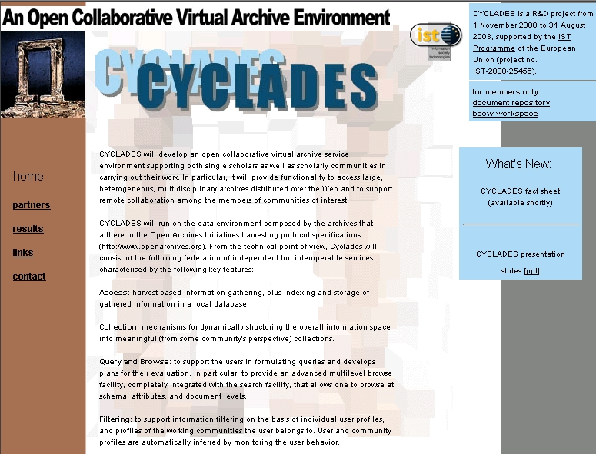

The server is run by ERCIM web dedicated staff and is regularly updated.

This site is composed of a public section and of a restricted area for the members, mainly used as a document repository. It was opened for public access in January 2000.

Public pages feature:

- General description of the project
- Links to member web sites (including e mail address of the contact person)
- Links to related projects, conferences and journals
- Events announcements
- Information concerning on-going activities within the 5 forums (including contact information)
- The public pages are also used to submit workshop proposals. Anyone, member or not, can send various topics to Delos in order to, eventually, set up a workshop on this relevant issue.

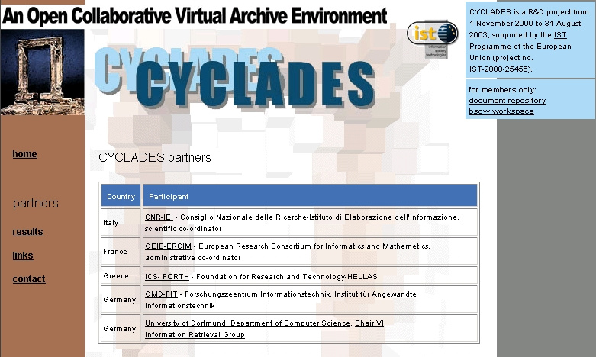

Partners Presentations and links in the public section

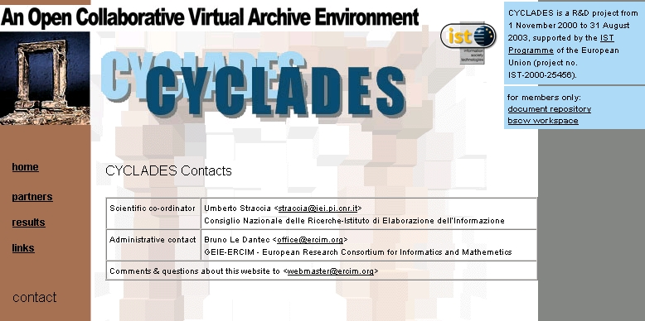

Contact web page in the public section

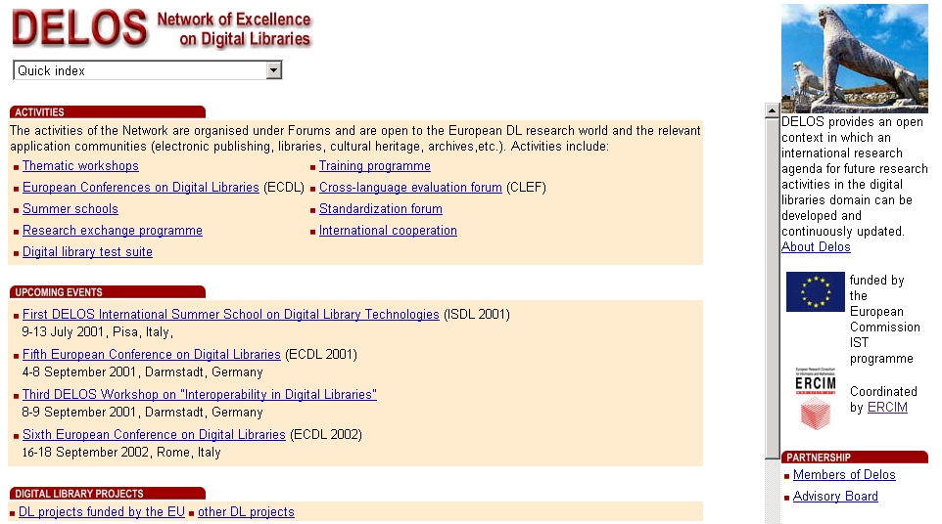

Direct Links to Related Projects

Restricted access area (restricted to partners)

- Full project proposal (With scientific part, partners description)
- Project meetings (announcement, minutes)
- Management reports, documents
- Administrative and financial guidelines
- Working documents
- Deliverables
- Link to BSCW

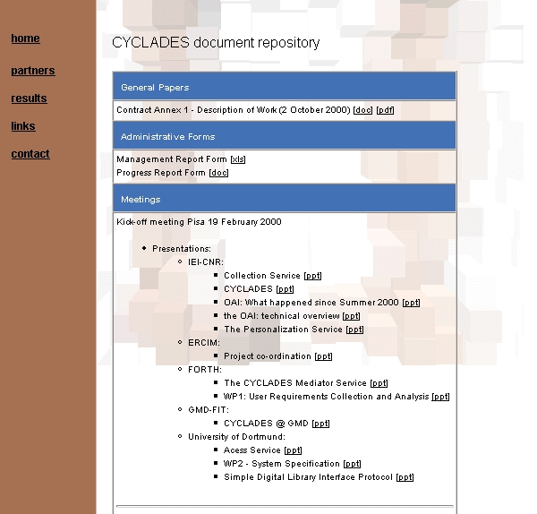

Cyclades Document Repository—Restricted Access

Partners are also extensively working together through the BSCW workspace. The Basic Support for Cooperative Work enables collaboration over the Web. BSCW is a 'shared workspace' system which supports document upload, event notification, group management and therefore grants the Cyclades partners additional flexibility when it comes to working together on a document.

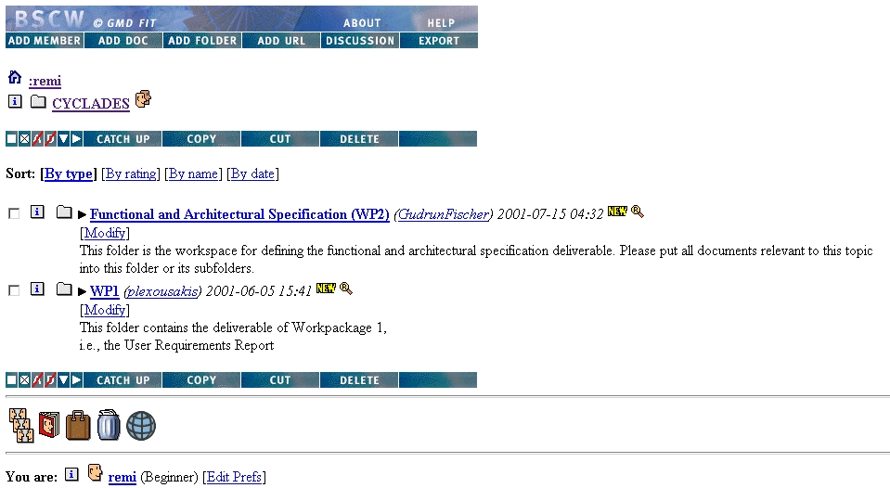

BSCW Workspace for Cyclades

Each dissemination document produced (or to to be produced) by the Cyclades partners, such as a fact sheet, refers directly to the web site.

Therefore and in conclusion, the Cyclades web site is not only an efficient Dissemination Tool at the center of the communication strategy, it is also a usefull Collaborative Tool, which with the BSCW, provides both the Cyclades partners and the Cyclades management additional flexibility.

